6,7,8 BJT
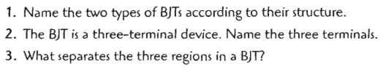
Ans. /
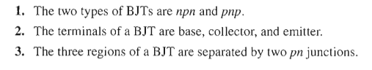
-----------------------------
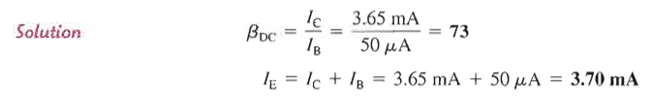
----------------------------------------
4- Draw a circuit used to record the control characteristics of npn BJT.
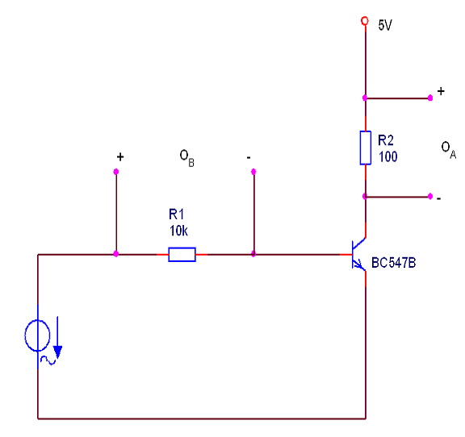
5- Draw the control ch/s of BJT common emitter

6- Why is the current amplification almost the same even though you have changed the collector resistance?
- The current amplification is constant due to the fact that the supply voltage has remained the same.
- The current amplification is essentially a transistor specific value and has nothing to do with the circuit.
- It is the series resistance at the base of the transistor that determines the current amplification and thus did not change.
7- Draw a circuit used to record the input characteristics of npn BJT.
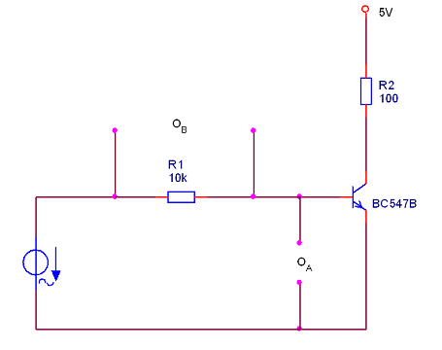

8- Which of the following statements about the transistor's input characteristic is correct?
- The characteristic corresponds to that of a resistor.
- The characteristic corresponds to that of a diode.
- The current through the base of the transistor initially increases very weakly and then abruptly.
- The voltage at the base is proportional to the current flowing through the resistor.
- The current flowing through the resistor is proportional to the voltage across the resistor.

9- Draw the input characteristics of BJT common emitter, what is look like ?
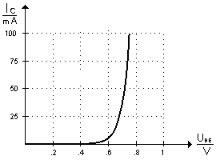 Like si-diode ch/s.

10- Draw a circuit used to record the output characteristics of npn BJT.
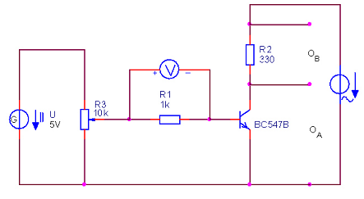
11- Draw the output characteristics of npn BJT.
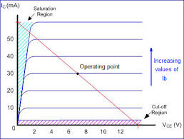

12 - What is the significance of the typical bend in the output characteristic?
- The oscilloscope cannot display any higher values on the y-axis.
- The preset base current is limited by the transistor's constant current amplification.
- The collector resistance limits the current flowing through the transistor.

